REPORT
Orientation Programme for First Year BCA and B.Com. Students
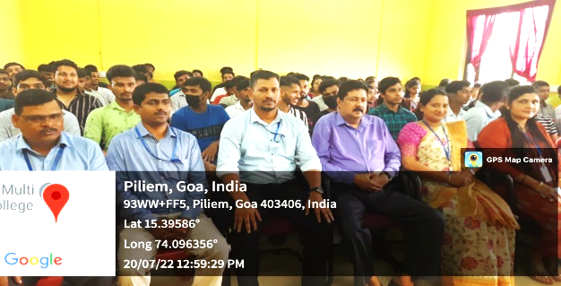
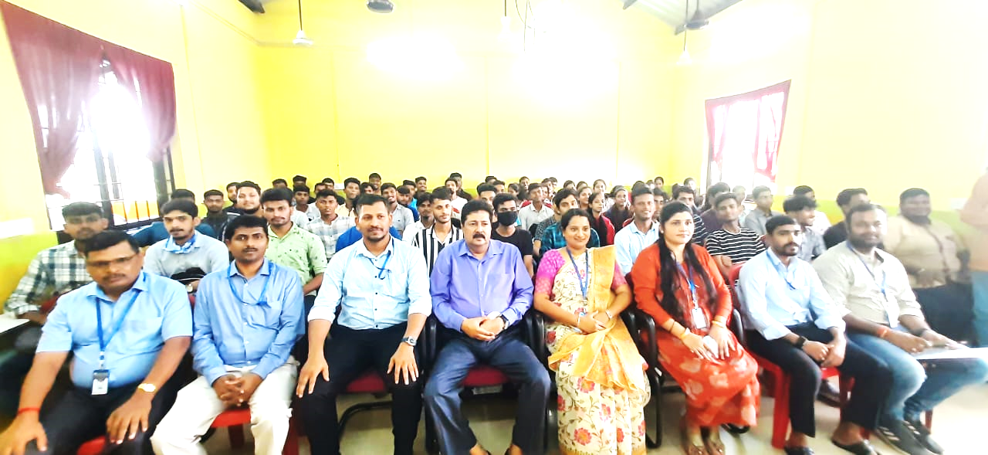
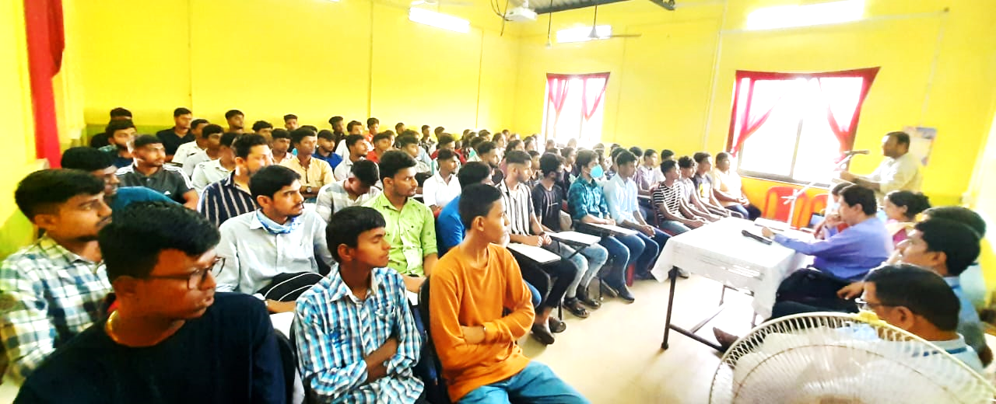
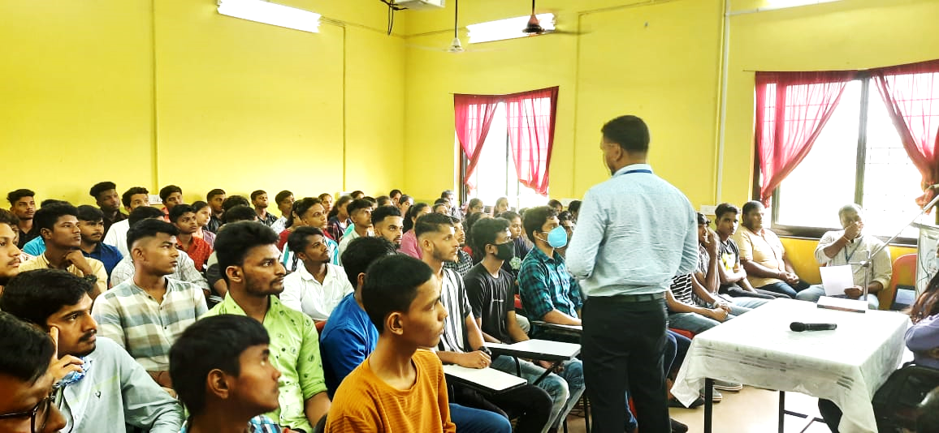
Date: 20th July 2022

SPES’s Goa Multi-Faculty College organized an Orientation Programme for the First Year Students of BCA and B.Com Course on 20th July 2022. The function began at 11.30 a.m. with a welcome note by Dr. Subasish Mohanty, Asst. Prof. in Commerce, who hosted the event, followed by a welcome address by Professor and Principal, Dr. Shaikh Mohammad Parvez Al-Usmani. He gave the overview of the Three Year BCA and B.Com. Courses and highlighted important aspects of the academics and co-curricular activities including the importance of maintaining 75% of attendance at minimum, Examination, Code of Conduct, use of library, actions taken in cases of Ragging and Sexual Harassment cases, etc. He also gave insight about the cultural activities, and sports activities.
Further, Mr. Neelesh Morajkar, Asst. Prof. in Commerce, gave the insight upon the Course Structure of Commerce. He mentioned the number of credits to be completed throughout the three years of course. He mentioned about the ISA and Semester End Examination and the eligibility criteria for answering SEE. Further, he spoke about the internships of one month for Commerce students. Similarly, Ms. Nilaxi Chari, Asst. Prof. in IT & Computer Applications, gave insight about the BCA Course, the credits to be completed in order to get the Bachelor’s Degree in Computer Applications, Mode of ISAs and eligibility criteria for answering SEE, and Internships.
Ms. Nilaxi Chari, made the students aware about the Conduct of Examination including the ISA and SEE Patterns and marks allotment for B.Com. and BCA Course examination. Further, she spoke on importance of maintaining 75% of Attendance at minimum and other related matters. Being the Chief Coordinator of IAIMS, she explained how IAIMS portal is used for keeping students records and generating mark-sheets of examination.
Mr. Neelesh Morajkar gave information about the Sports Club / Activites. He also highlighted few points of Code of Conduct which students have to adhere to. This was followed by the information about the Cultural Club and NSS unit by Dr. Ulhas Bansode, Asst. Prof. in Commerce. Mr. Ajit Faras, College Librarian, highlighted various scholarships that students can avail and also gave insight about the library facilities in the college.
Further, Dr. Subasish Mohanty, spoke about the internship and placements under various organizations who have done MoU with our college. Mr. Rajendra Gounder, Asst. Professor in Economics, made the students aware about the Canteen facilities available in the college campus and the transportation facilities and the procedure to avail the bus pass. Then, Ms. Kalpita Naik, Asst. Prof. in Commerce, spoke about the mentoring and counselling facilities available in the college. The programme was called off with a Vote-of-Thanks by Mr. Rajendra Gounder.

Report drafted by Ms. Nilaxi Chari, Asst. Prof. in IT & Computer Applications

