REPORT
Orientation Programme for Second year and Third year of B.Com. Students
Date: 21st July 2022

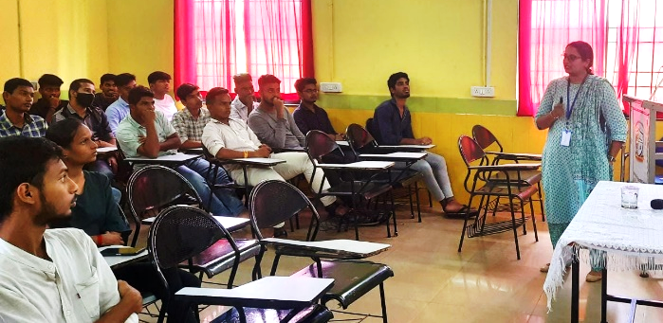
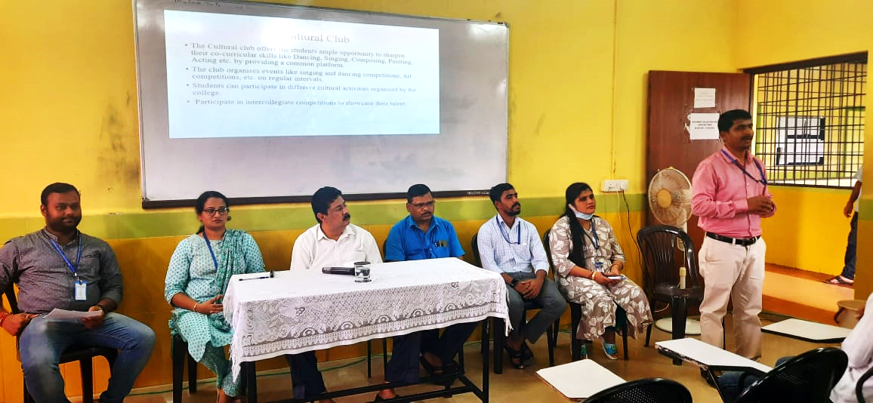
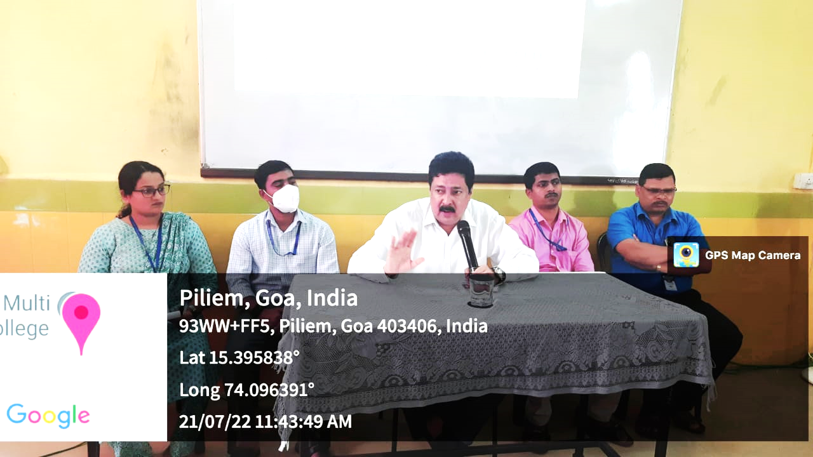
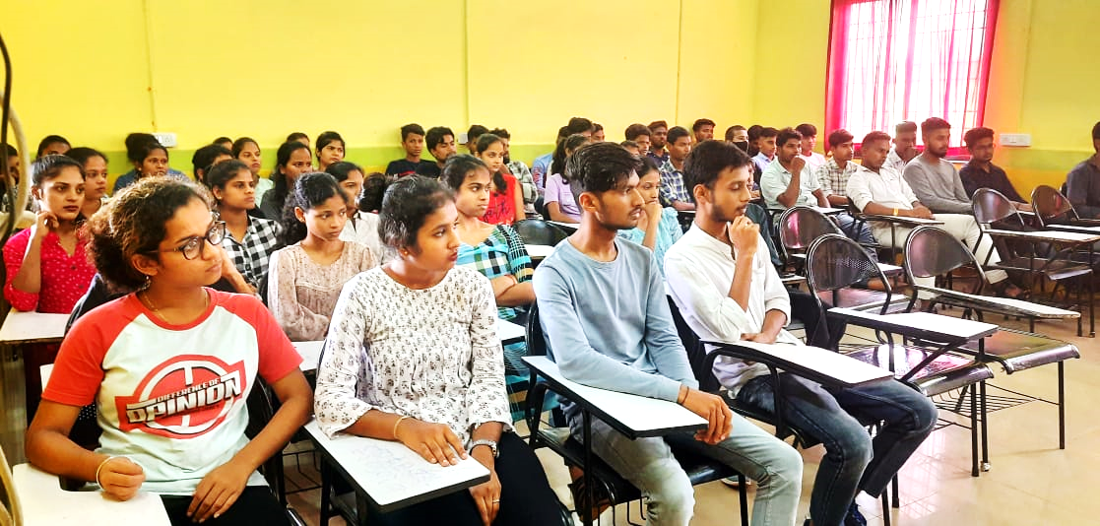

SPES’s Goa Multi-Faculty College organized an Orientation Programme for the Second and Third year students B.Com Course on 21st July 2022. The function began at 12.40 p.m. with a welcome note by Dr. Subasish Mohanty, Asst. Prof. in Commerce, who hosted the event for SY and TY B.Com students, followed by a welcome address by Professor and Principal, Dr. Shaikh Mohammad Parvez Al-Usmani. He gave the overview of the Three Year B.Com Course and highlighted important aspects of the academics and co-curricular activities including the importance of maintaining 75% of attendance at minimum, Examination, Code of Conduct, use of library, available scholarship facilities, transportation facilities, NSS, sports, cultural activities etc.
Ms. Nilaxi Chari, spoke about B.Com course credits to be completed in order to get the Bachelor’s Degree in Commerce, mode of ISAs and eligibility criteria for answering SEE. She stressed upon submission of ISA assignments before the due date and asked the students to maintain 75% of attendance at minimum to be eligible for answering the SEE examination. Being the Chief Coordinator of IAIMS, she explained how IAIMS portal is used for keeping students records, ISA and SEE marks and for generating mark-sheets of examination.
Further, she touched upon the points regarding the entitlement marks for sports and few points of Code of Conduct which students have to adhere to. This was followed by the information about the Cultural Club and NSS unit by Dr. Ulhas Bansode, Asst. Prof. in Commerce. Mr. Ajit Faras, College Librarian, highlighted various scholarships that students can avail and gave insight about the library facilities in the college.
Further, Dr. Subasish Mohanty, spoke about the internship and placements under various organizations who have signed MoU with our college. Mr. Rajendra Gounder, Asst. Professor in Economics, made the students aware about the Canteen facilities available in the college campus and the transportation facilities and the procedure to avail the bus pass. Ms. Kalpita Naik, Asst. Prof. in Commerce, gave information about the class mentoring and counselling facility available in the college.
Finally, Mr. Neelesh Morajkar, Asst. Prof. in Commerce, proposed Vote-of-Thanks and the programme was called off at 1.30 p.m.

Report drafted by Ms. Nilaxi Chari, Asst. Prof. in IT & Computer Applications

